Lesson 7 Demo 6
Docker Networking with SSHs
Objective: How to use Docker Network and its configuration

Tools required: Docker Configuration

Pre-requisites: Ubuntu Configuration, Docker

Steps to be followed:
- Creating a container and committing it
- Creating a bridge network and finding its IP address
- Connecting the network from another SSH server

Step 1: Creating a container, and commit it
1.1 Create a Centos Docker container. and install net-tools
sudo docker run -it --name centos centos /bin/bash
yum install -y net-tools
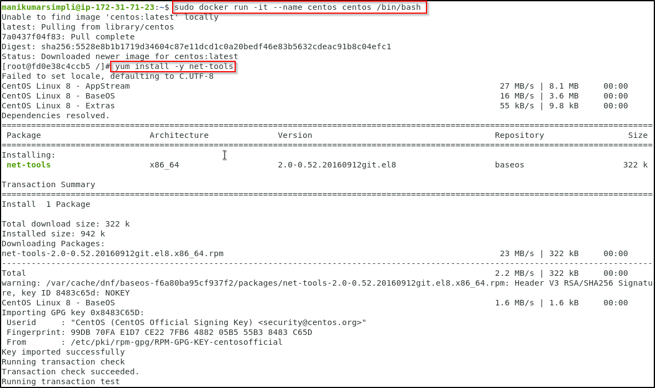
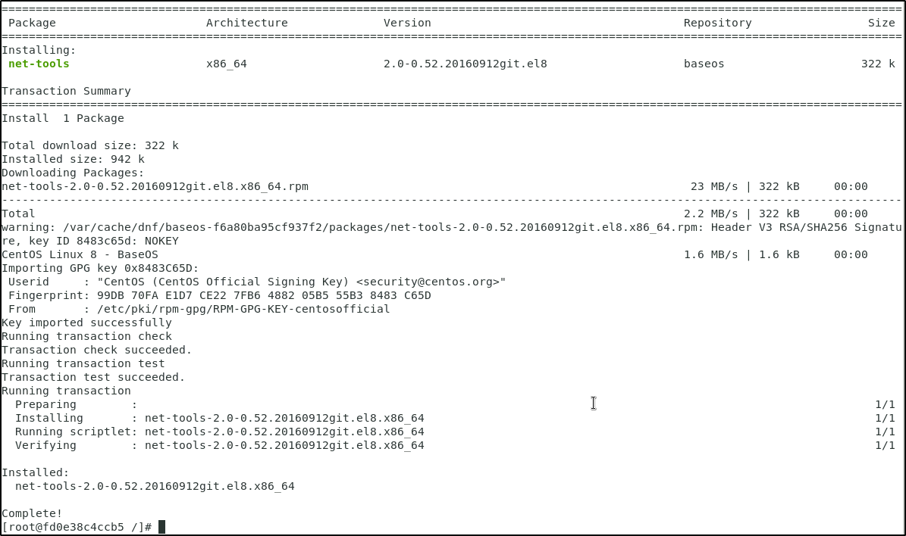

1.2 Check the IP address and hostname
ifconfig
cat /etc/hosts
hostname
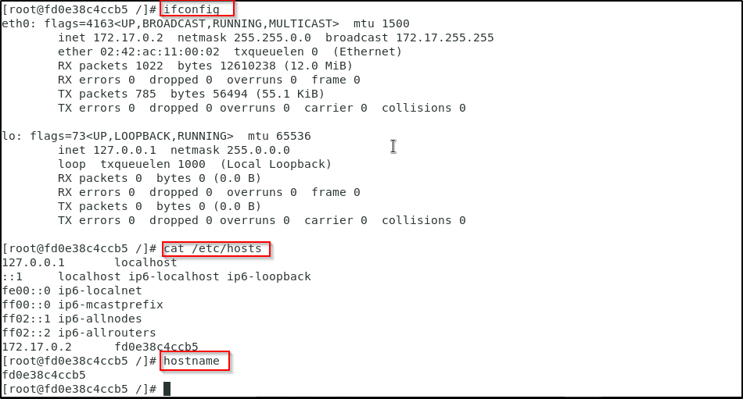
1.3 Exit the container using CTRL+D
1.3.1 Commit the container to an image (Please refer to the screenshot)
docker commit centos centos-net
docker images
docker rm centos
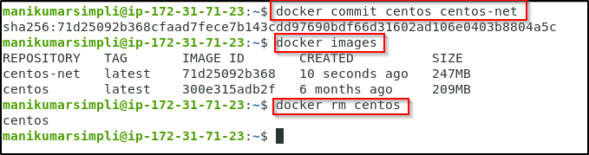
Step 2: Creating a bridge network, and find its IP address
2.1 Create a bridge network, and find its IP range
docker network create exnet
docker network ls
docker network inspect exnet
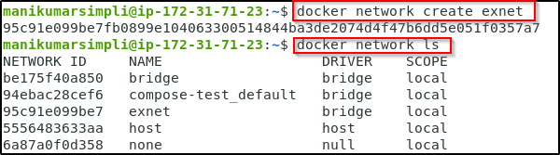
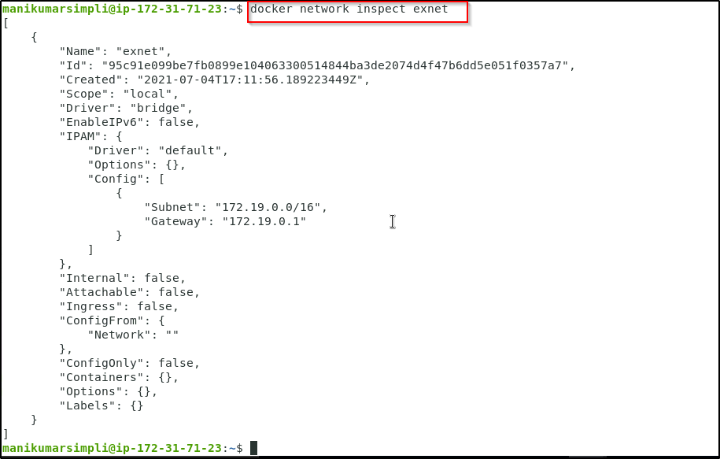

2.2 Run the centos container using the new network
docker run -it --rm --network exnet centos-net /bin/bash

2.3 Check the IP address and hostname
ifconfig
cat /etc/hosts
hostname
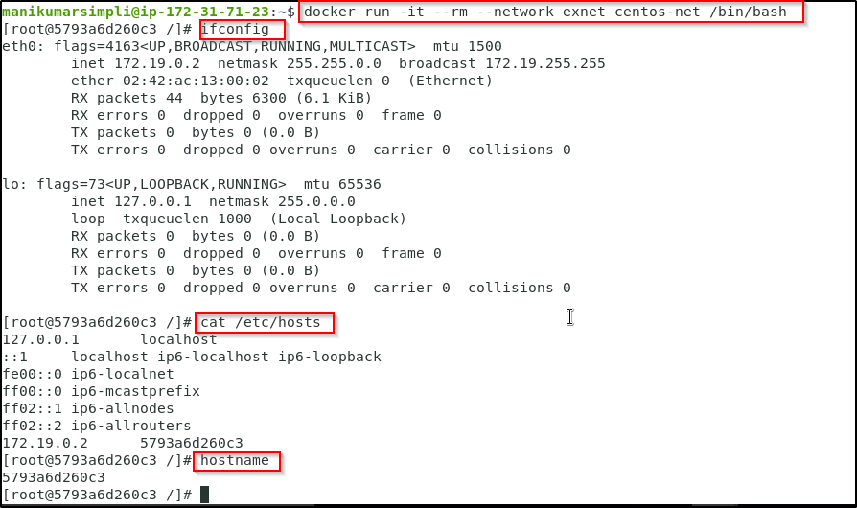

2.4 Exit the container using CTRL+D
2.4.1 Start a new container using the default network
docker run -it --rm --name centos centos-net /bin/bash
2.5 Check the IP address and hostname
ifconfig
cat /etc/hosts
hostname
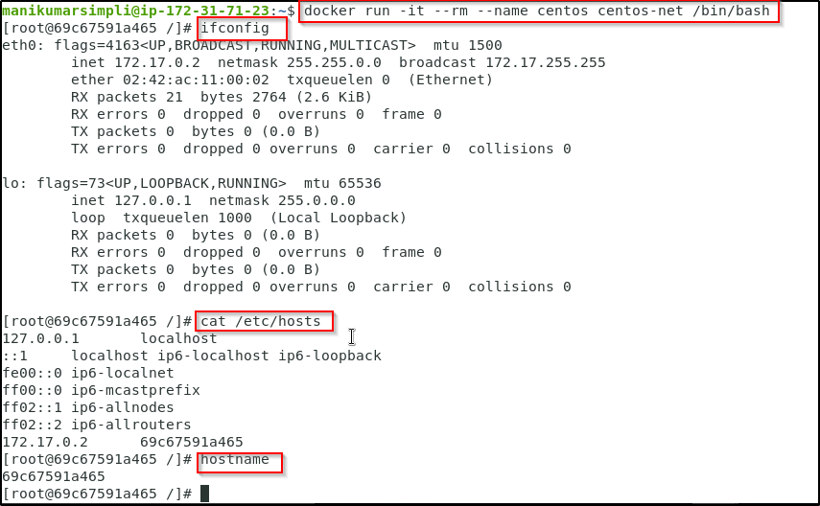
Step 3: Connecting the network from another SSH server
3.1 Click on + to open another Terminal window. Type the below given command to from the second SSH terminal to connect the network to the container
docker network connect exnet centos
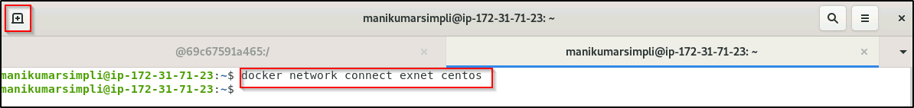

3.2 Go back to the running container. You will see that it now has two IP addresses (Please refer to the screenshot)
ifconfig
cat /etc/hosts
hostname
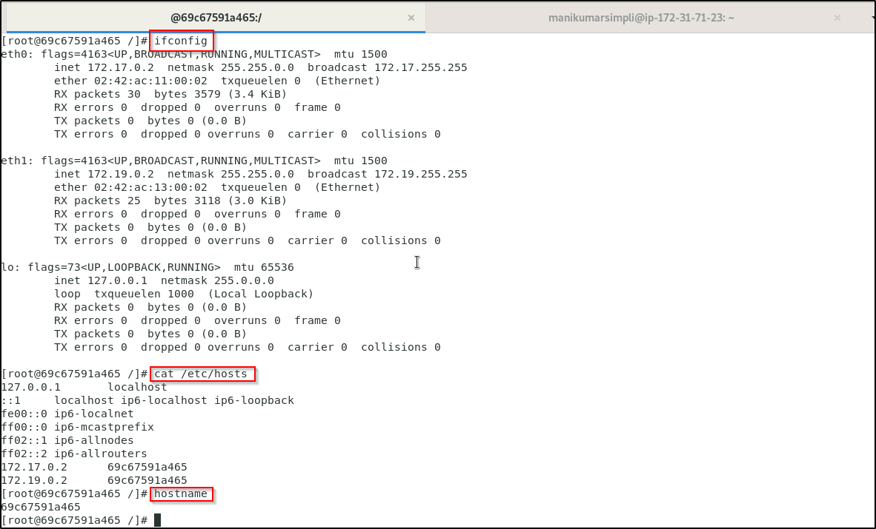

3.3 Go to the second SSH window, and disconnect the network
docker network disconnect exnet centos
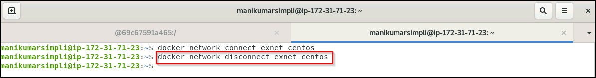
3.4 Go back to the running container, and see that it now has one IP address
ifconfig
cat /etc/hosts
hostname
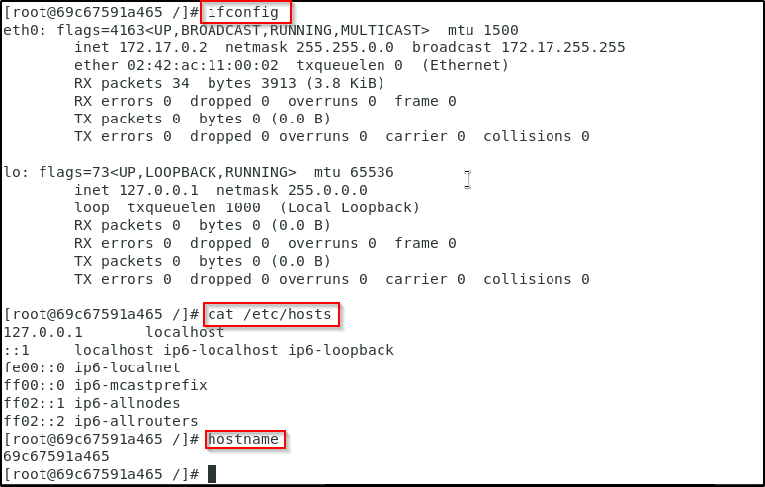
3.5 Exit the container using CTRL+D

